Seventeenth NorthAmerica/Europe Data Exchange Meeting

UK Met Office Telecommunications Status Report 2004

Prepared By:

David Hennings
Message Switching Team Tel: +44 (0)1392 884092
Met Office Fax: +44(0)1392-885681
Fitz roy Road e-mail:david.hennings@metoffice.com
Exeter, Devon
EX1 3PB, UK

1. Communication Links
Figure 1 UK Met Office Telecommunication links
Figure 1 shows some of the UK Met Office telecommunications links. The message switches FROST, TROPICS and NETlink send and receive data arriving over the links while the routers EXERT5 (and EXERT6) provide the connections to the circuits or managed network services.
The TROPICS message switch has mostly been replaced by the new FROST message switch .
The Regional Meteorological Data Communications Network (RMDCN) is a managed IP network service provided by Equant for the WMO National Meteorological Services (NMSs) in WMO region VI. RMDCN also supports X25 encapsulated in IP (XOT).
The Met Office has Frame Relay links with both British Telecom (Link to Australia BoM, and NOAA-OSO) and MCI Worldcom (Link to NOAA-NESDIS and CMC).

The following sections contain more detailed information on some of the links.

1.1 Links to NOAA
There are two links to NOAA, one to NOAA-NESDIS and a second to the NOAA Office of Systems Operations (NOAA-OSO).

1.2.1 Links to NOAA-OSO
The link to NOAA-OSO is a Frame relay line. There are two separate sockets data streams described in Table 1. The link utilisation is shown in Appendix A.

Protocol | NOAA-OSO System | Met Office | Data
TCP Sockets | NOAA-OSO Telecommunications Gateway | FROST | GTS
TCP Sockets | NOAA-OSO Telecommunications Gateway | FROST | T4 Fax Products
Table 1 Details of the links between METO and NOAA-OSO
(The leased line between Bracknell and Washington has now been replaced with a Frame Relay connection operating from Exeter.)

1.2.2 Links to NOAA-NESDIS
The Frame Relay link to NOAA-NESDIS is used for the transfers of satellite sounding data. Details on the link is shown in Table 2, the utilisation is shown in Appendix A and the daily volumes of data is shown in Table 4.

Speed Kbits/sec | Protocol | NOAA-NESDIS System | Met Office | Data
512 Access/ 128 CIR from NESDIS | FTP | CEMSCS | NETLINK | Satellite Sounding data and products, see Table 4
512 Access/32CIR to NESDIS | FTP | CEMSCS | NETLINK | ERS-2 Data
Table 2 Details of the links between Met Office and NOAA-NESDIS

1.2 Links to ECMWF
The 2MBits/Sec link to ECMWF is used to transmit files of data between Met Office and ECMWF using TCP/IP protocols. This data includes GTS Data, numerical modelling products and satellite data. Met Office users can also submit jobs to run on the ECMWF Supercomputer and access data on ECMWF computer systems using their MARS and METVIEW software.

1.3 Links to RMDCN
The link from Met Office to the RMDCN network has an access speed of 512 Kbits/S (ISDN backup 384Kbits/S). Permanent Virtual Circuits (PVCs) are established across RMDCN to other National Meteorological Services (NMSs) in WMO region VI. The details of some of the most used these are described in this section.

1.3.1 Links to Météo-France
PVC with a speed of 256Kbits/Sec out (Met Office to Météo-France) with agreed upgrade to 384Kbits/S, and 128Kbits/Sec in (Météo-France to Met Office).
The link is used for:
- Exchange of GTS and Radar data.
- Sending GOES and GMS satellite data to Lannion. This data is then sent from Lannion to METEOSAT for rebroadcast.
- Transmission of Met Office NIMROD products.
- Transmission of NOAA satellite sounding data such as the SSM/I and ATOVS data .
- Receipt of SAF OCEAN/ SST and ICE (planned) products. Poorman’s Ensemble data and NWP Precpitiation

1.3.2 Links to DWD
A PVC with a speed of 64Kbits/Sec in both directions has been established between the Met Office and DWD to exchange GTS products.

1.3.3 Other RMDCN Links
The MET OFFICE has the following PVCs through RMDCN to other NMSs

National Meteorological Service | Protocol | PVC Speed Kbits/Sec | Status
Belgium (Brussels) | FTP | 32 Both ways | Operational
Denmark | TCP Sockets | 32 Both ways | Operational
DWD | FTP | 64 Both ways | Operational
Iceland (Reykjavik) | FTP | 8 Both ways | Operational
Ireland (Dublin) | FTP | 64 Both ways | Operational
Italy (Rome) | FTP | 16 Both ways | Operational
Météo-France | FTP | 128 in  256 out [384*] | Operational
Russian Federation (Moscow) | FTP | 8 in/64 out* | Operational
Netherlands (De Bilt) | TCP Sockets | 64 Both ways | Operational
Norway (Oslo) | TCP Sockets | 32 Both ways | Operational
Portugal | FTP | 32 Both ways | Operational
Spain | TCP Sockets | 32 Both ways | Operational
Table 3 Details of RMDCN Links to other NMSs in WMO Region VI

United Kingdom
PVC to | CIR (kbps)  in | CIR (kbps)  out | NRT (ms)  specified | Service (%) availability
Belgium | 32 | 32 | 110 | 99.5
Denmark | 32 | 32 | 130 | 99.5
France | 128 | 256 | 170 | 99.5
Germany | 64 | 64 | 130 | 99.5
Iceland | 8 | 8 | 170 | 99.5
Ireland | 64 | 64 | 90 | 99.5
Italy | 16 | 16 | 130 | 99.5
Netherlands | 64 | 64 | 140 | 99.5
Norway | 32 | 32 | 130 | 99.5
Portugal | 32 | 32 | 220 | 99.5
Russian Federation | 8 | 64 | - | 99.5
Spain | 32 | 32 | 140 | 99.5
Table 4. Details of RMDCN Links from http://rmdcn.ecmwf.int/RMDCN.html

1.4 Other International Links
In an effort to gain routine, reliable access to global imagery from geostationary satellites, the Met Office has implemented links as described briefly below. The approach has generally sought to identify mutual benefit from the exchange of satellite data and, hence, sharing of the costs involved.

1.4.1 Australian Met. Service
A Frame Relay link has been established between the Met Office and the Australian Bureau of Meteorology (BoM) in Melbourne. The access speed is 256Kbits/Sec at each end and the CIR is 64Kbits/Sec in both directions. The link is being used for the exchange of data in WMO bulletin format using TCP sockets with FROST, files of satellite imagery (METEOSAT from UK and GMS from Australia) and ATOVS (HIRS) level 1D data with NETLINK.

1.4.2 Canadian Met. Service
A 32 Kbits/Sec Frame Relay link has been established between the Met. Office and the Canadian Met. Service (CMC) in Dorval. It is being used for the exchange of data in WMO bulletin format with FROST and files of satellite data (METEOSAT from UK and GOES from Canada) with NETLINK.

2. Met. Office Communication Computer Systems
There are two main computer systems at the Met Office that are used to send data to customers. The HP-UNIX-based FROST message switch sends WMO messages using FTP or TCP/IP sockets. FROST is planned to have some X25 Over TCP/IP capability later this year though most remaining X25 customers are encouraged to migrate to FTP or TCP sockets.
The TROPICS system, which is shortly to be retired, handles communications using direct X25 links and X25 over TCP/IP (including GTS traffic to CMC).
The NETLINK system exchanges files using FTP. In general FROST is used for the transfer of low volume data, typically from 100 Bytes to 50 Kbytes, where high speed data switching is important. NETLINK is used for the distribution of higher volume data at slower data switching speeds.

2.1 NETLINK
The NETLINK computer system is responsible for the operational transfer of files of data between computers on the Met. Office Central Data Network (CDN) and computers on external networks. It consists of two identical Compaq Alpha Computers running OpenVMS, the main node is called NETTLE and its backup is called TEAZLE.
Each NETLINK node is a HP Alpha 1200/533 with 256 Mbytes of memory running OpenVMS V7.3-1 operating system. Currently the system is switching 44,000 files per day, which is about 28 Gbytes of data.
Planning is in its early stages to replace the functionality of NETLINK with a new platform which integrates better with the new FROST system sometime in 2006.
In the mean time, to handle anticipated loading from Meteosat Second Generation (MSG) and some of the new satellite product sets, the nodes will be replaced by more powerful OpenVMS (HP Alpha) platforms.

Table 5 below, shows the data and its associated volumes sent to NETTLE over the Frame Relay link at present.

Requirements Description | Daily Data Volume (MBytes)
NOAA AMSU-A Level 1B | 92
NOAA AMSU-ABLevel 1B | 330
DSMP SSM/I Brightness temperatures | 220
NOAA TOVS MSU Level 1B | 1
NOAA TOVS SSU Level 1B | 13
QuikScat Scatterometer data | 209
NOAA AVHRR Products on a HIRS Grid. | 35
NOAA AVHRR 100km and 50Km SSTs | 7.9
NOAA AVHRR Mapped Global Area Composites | 6.3
NOAA Ozone Retrieved profiles and/or total column from SBUV | 1.2
AQUA AIRS Brightness temperatures | 300
AQUA AMSU-A Brightness temperatures | 11.5
NOAA TOVS HIRS Level 1B | 45.7
NOAA ATOVS HIRS Level 1B | 206.7
GOES cloud-tracked VIS/IR/WV Winds | 8.4
TOTAL | 1487.7

Table 5 Data Volumes from NESDIS to Met Office

Table 7 shows the anticipated increase in data volumes over the next year based on the data in the present European requirements list.
The expected increase in link capacity required to be able to accommodate that data is also shown.
The present link runs well below the frame relay access speed of 512Kb/s.
Currently the average is ~10% greater than the committed information rate (CIR) of 128 Kb/s, and will rise to +30% above CIR later this year with SSM/IS.
This speed could drop to the CIR if the supplier’s network becomes congested.
It has been previously proposed that the link is operated at a CIR similar to the average daily data rate with an access speed four times that value.

As long at the network continues to operate at the access speed there should be sufficient bandwidth and if the network becomes congested and the data rate drops we can pay to increase the CIR (up to 80% of the access speed).

At an earlier meeting of this Data Exchange group, a document containing options for backing up the data on the NESDIS link was prepared for discussion. The option selected was to routinely copy high priority data (defined as data crucial to operations) from the CEMSCS system at NESDIS to the NOAA-OSO FTP Server. In the event of a problem with the NESDIS link MET OFFICE would pull the data from this server over the NOAA-OSO GTS link and then pass it to the NETLINK system for processing.

The European Met Services provided information on the priority for the data sets on the dedicated link shown in Table . From the information provided it was decided to proceed with backing up the ATOVS level 1B data sets. Access to files on the NOAA-OSO server from Bracknell over the NOAA-OSO GTS link was successfully tested (in 2002). There is a requirement to reacquire the knowledge as to how this procedure works by Met Office staff working from Exeter.

Data Set | MET OFFICE | ECMWF | Météo-France
ATOVS Level 1b | 1 | 1 | 1
AVHRR 100/50 km SST | 3 | 4 | 3
AVHRR Mapped Images | 2 | 4 | 3
AVHRR products for HIRS | 3 | 3 | 3
GOES AMVs | 1 | 1 | 3
SSM/I Sea Ice | 4 | 1 | 4
TOVS Level 1B | 4 | 1 | 4
SBUV Ozone | 3 | 2 | 3
Quikscatt | 1 | 1 | 2
SSM/I BTs | 1 | 1 | 2
Table 6 Priorities for Data Sets on Exeter-NESDIS dedicated link

Categories are:
- High Priority (crucial for operations)
- Medium Priority (operational or pre-operational use but not critical
- Low Priority (research datasets)
- No Requirements

Date | Data Volume (Mbytes) | Average Link Speed (Kbits/Sec) | Link CIR (Kbits/Sec) | Link Access Speed (Kbits/Sec) | Additional Data Requirement
01/07/2000 | 650.0 | 61.6 | 64 | 256
01/10/2000 | 862.3 | 81.7 | 64 | 256 | NOAA-L
01/01/2001 | 862.3 | 81.7 | 64 | 256
01/04/2001 | 862.3 | 81.7 | 64 | 256
01/07/2001 | 1043.5 | 98.9 | 128 | 512 | Quickscatt NOAA-L AVHRR
01/10/2001 | 1073.5 | 101.8 | 128 | 512 | NOAA-L AVHRR
01/04/2002 | 1073.5 | 101.8 | 128 | 512
01/07/2002 | 1473.3 | 139.7 | 128 | 512 | NOAA-M AMSU & AVHRR
01/03/2004 | 1420 | 134.6 | 128 | 512 | AIRS and AMSU on AQUA
01/08/2004 | 1728 | 163.8 | 128 | 512 | SSM/IS,
Table 7. Data Volumes on the NESDIS Frame Relay Link.

2.2 FROST
The new Met Office FROST system is based upon a pair of HP L3000 servers running HP-UX Operating System software configured to run as a main system and a hot standby. There is a separate HP A500 Test & Development server.
A dedicated gigabit Ethernet link between the systems is used for management traffic and data synchronisation.
Application software is based upon the Messir-Comm message switching package for WMO message switching supporting FTP and TCP sockets. This is integrated with Nexor Mailer/Mixer software for general message switching using X.400 and SMTP. Legacy X.25 communications is supported by a pair of CISCO 3640 routers hot-switchable between servers. Operations and management of the system is performed using client software running on standard desktop PCs augmented by integration of the system with existing Met Office Tivoli and OpenView management platforms.
When migrating the Washington link from TROPICS to FROST, protocols were changed to use TCP sockets rather than X25.

The data volumes between Washington and Exeter are shown in Tables 4; 5 & 6 from the Frost Message Switch.

Date | Washington to Exeter |  | Exeter to Washington
 | Data (Mb) | Msgs | Data (Mb) | Msgs
April 1996 | 9.2 | 14256 | 9.1 | 13651
May 1997 | 9.6 | 15535 | 10.4 | 14662
May 1998 | 13.2 | 16524 | 11.0 | 15884
May 1999 | 17.5 | 18036 | 12.4 | 19199
June 2000 | 21.3 | 22123 | 14.2 | 24359
April 2001 | 32.7 | 23011 | 16.4 | 28925
June 2002 | 41 | 31354 | 18 | 32247
April 2003 | 35.6 | 28259 | 37.3 | 29612
May 2004 | 44.6 | 36961 | 17.1 | 29268
Table 8 GTS Link Alpha-Numeric Channel

Date | Washington to Exeter |  | Exeter to Washington
 | Data (Mb) | Msgs | Data (Mb) | Msgs
April 1996 | 72.8 | 19455 | 75.9 | 23463
May 1997 | 75.6 | 19220 | 77.3 | 23007
May 1998 | 80.1 | 19932 | 66.5 | 16259
May 1999 | 78.7 | 19876 | 68.7 | 16343
June 2000 | 83.1 | 20389 | 75.3 | 17763
April 2001 | 86.1 | 20740 | 86.6 | 20006
June 2002 | 163 | 36186 | 119 | 24961
April 2003 | 182 | 38834 | 130 | 27687
May 2004 | 181.4 | 40803 | 164.3 | 29302
Table 59GTS Link GRIB Channel

Date | Washington to Exeter |  | Exeter to Washington
 | Data (Mb) | Msgs | Data (Mb) | Msgs
April 2001 | 5.4 | 59 | 5.4 | 60
June 2002 | 3 | 33 | 6 | 68
April 2003 | 3.3 | 33 | 7.5 | 74
May 2004 | 3.4 | 38 | 6.7 | 74
Table 10 GTS Link T4 Channel

The data volumes between Toulouse and Exeter are shown in Tables 7; 8 & 9 from the Frost Message Switch.

Date | Toulouse to Exeter |  | Exeter to Toulouse
 | Data (Mb) | Msgs | Data (Mb) | Msgs
May 2004 | 39.6 | 16785 | 71.3 | 47490
Table 11 GTS Link Alpha-Numeric Channel

Date | Toulouse to Exeter |  | Exeter to Toulouse
 | Data (Mb) | Msgs | Data (Mb) | Msgs
May 2004 | GRIB received on alpha channel |  | 98.2 | 27897
Table 12 GTS Link GRIB Channel

Date | Toulouse to Exeter |  | Toulouse to Toulouse
 | Data (Mb) | Msgs | Data (Mb) | Msgs
May 2004 | 18 | 1203 | 57.7 | 1476
Table 13 GTS Link T4 Channel

The data volumes between Washington and Bracknell are shown in Table7, Table8
& Table9.They show a large increase in GRIB data transferred, this is due to the addition of GRIB data exchange from model runs at 06Z and 18Z in the last year. The graph of link utilisation in Appendix A shows there are now daily four peaks which is the GRIB data exchange.

3 Met Office Relocation

The Met Office has moved to Exeter in the South West of the UK, around 170 miles from the previous location in Bracknell.
At the new site there are two separate IT Halls. Diversely routed communication ducts to each hall enable highly resilient communication circuits.
Migration of computer systems and circuits is complete with the present building in Bracknell having closed.

Appendix A. Utilisation of UK Met. Office Links to NOAA
Utilisation of UK Met. Office Links

Following are utilisation graphs for the following links:

- Washingtom – NOAA OSO
- RMDCN
- Dorval – CMC
- ECMWF

Note on the graphs which follow:
We are currently in the process of investigating new network monitoring tools, as the previous product has been dropped by the supplier. The following graphs have been captured from a basic OpenView monitoring package and as such are not ideal.

A1 Links to NOAA-OSO

A1.1 Utilisation of GTS Link from MET OFFICE from NOAA-OSO

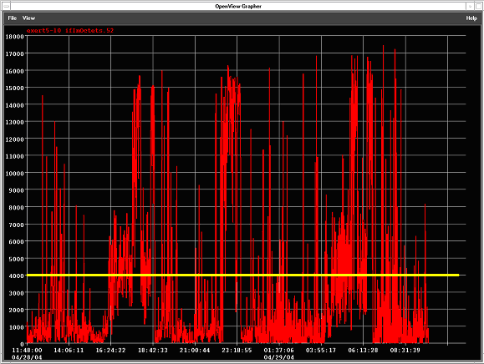

CIR marked as yellow horizontal line

A1.2 Utilisation of GTS Link from MET OFFICE to NOAA-OSO

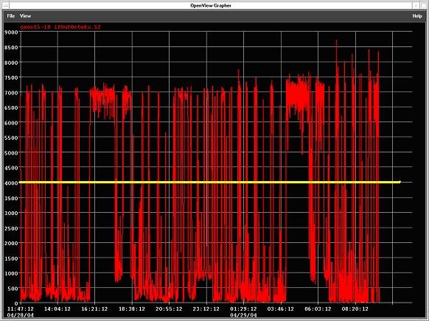

CIR marked as yellow horizontal line.

A2.1 Frame Relay Link to NOAA-NESDIS

CIR 128 Kbits/s (32K Octets) [Access: 512Kbits/s]
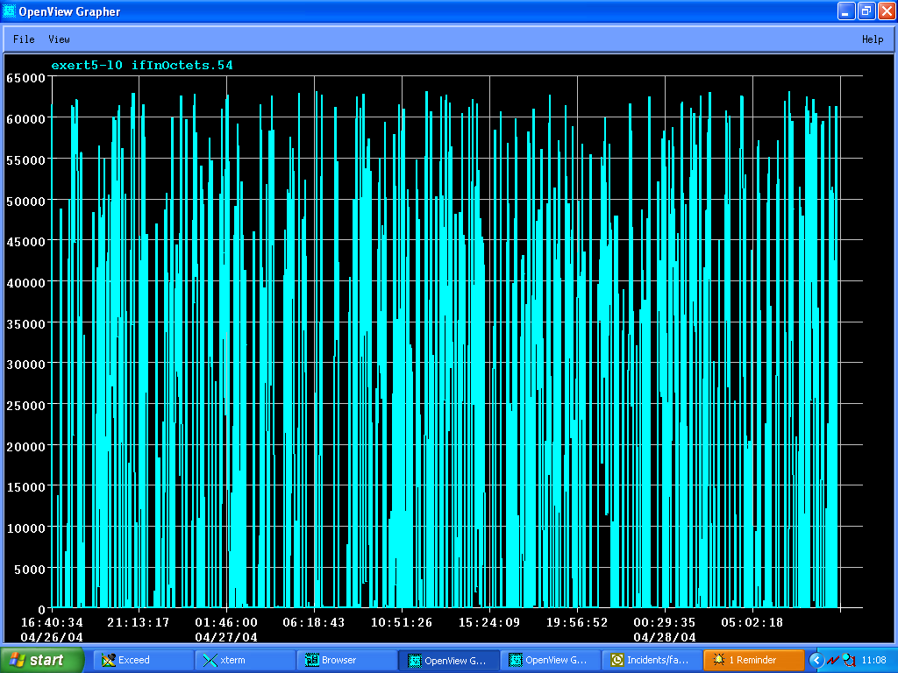

The graph shows the input utilisation of the Frame Relay link to NESDIS relative to a bandwidth of 512Kbits/Sec which is the access speed of the frame relay circuit in April 2004. The peak usage exceeds the CIR of 32K octets/sec by a factor of two.

A2.1 Frame Relay Link from NOAA-NESDIS

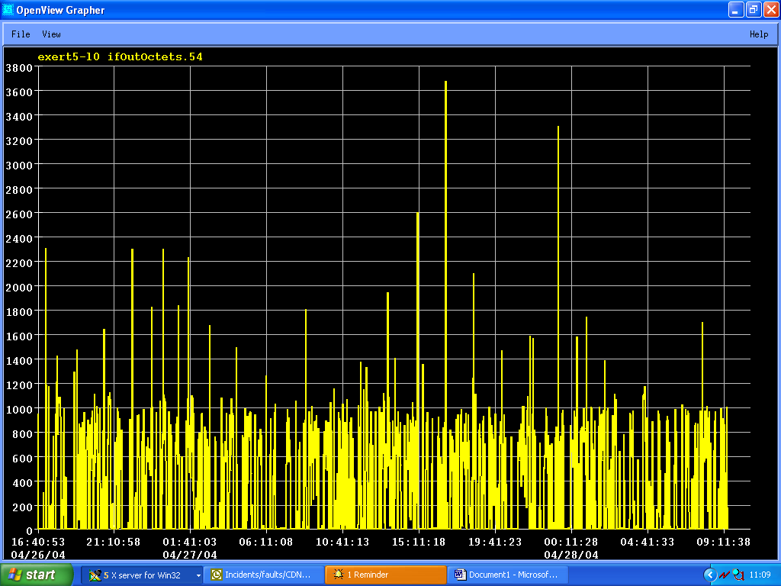

Well within the CIR of 32K octets/sec

A3 RMDCN

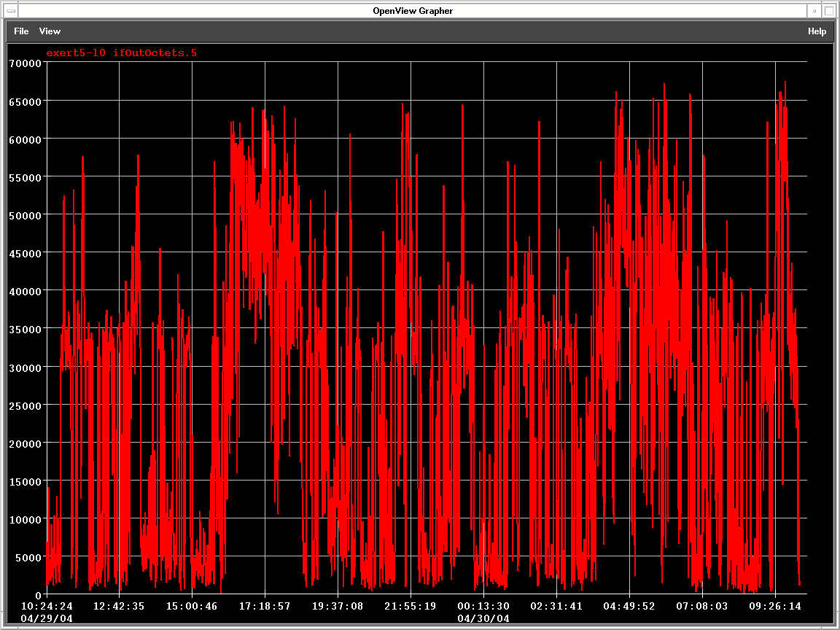

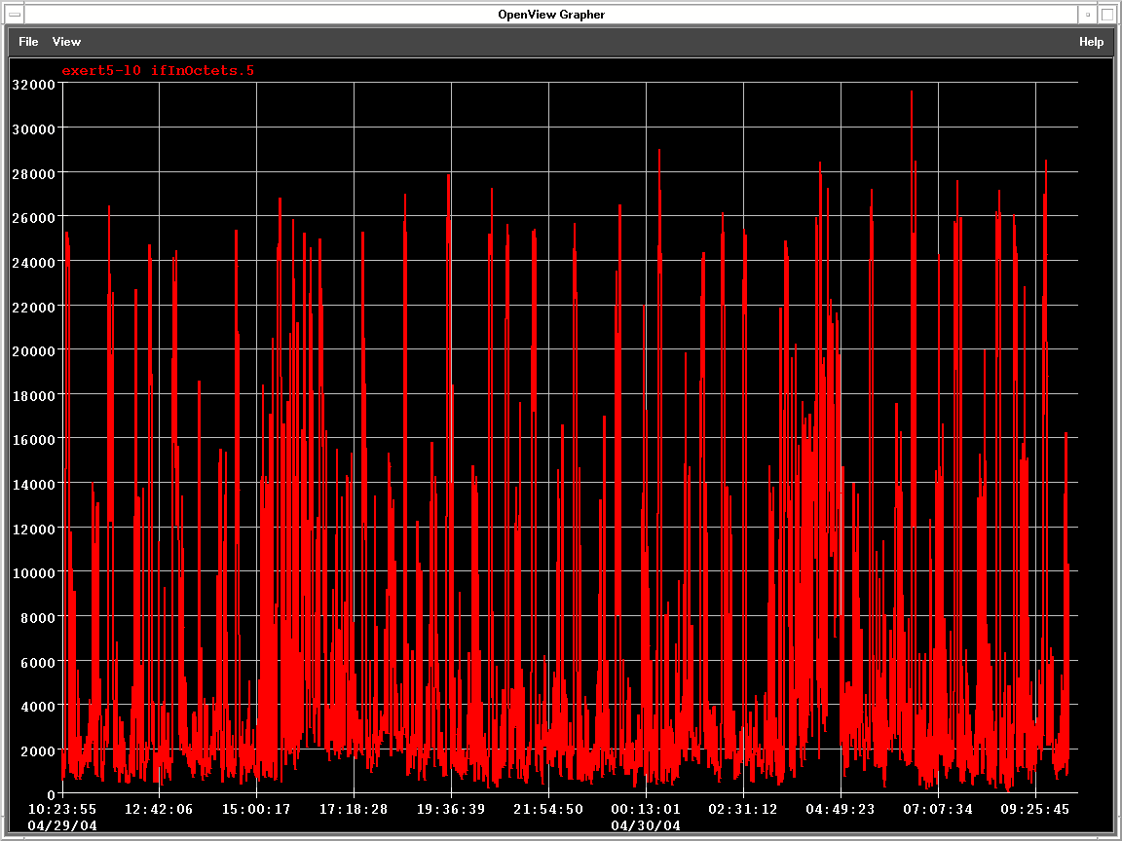
A4 Dorval CMC

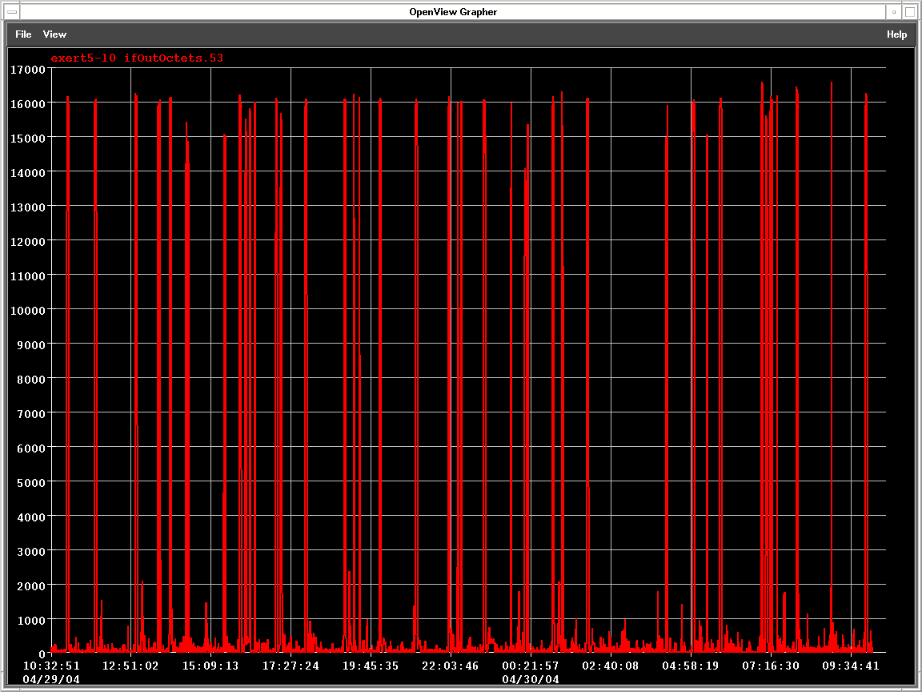

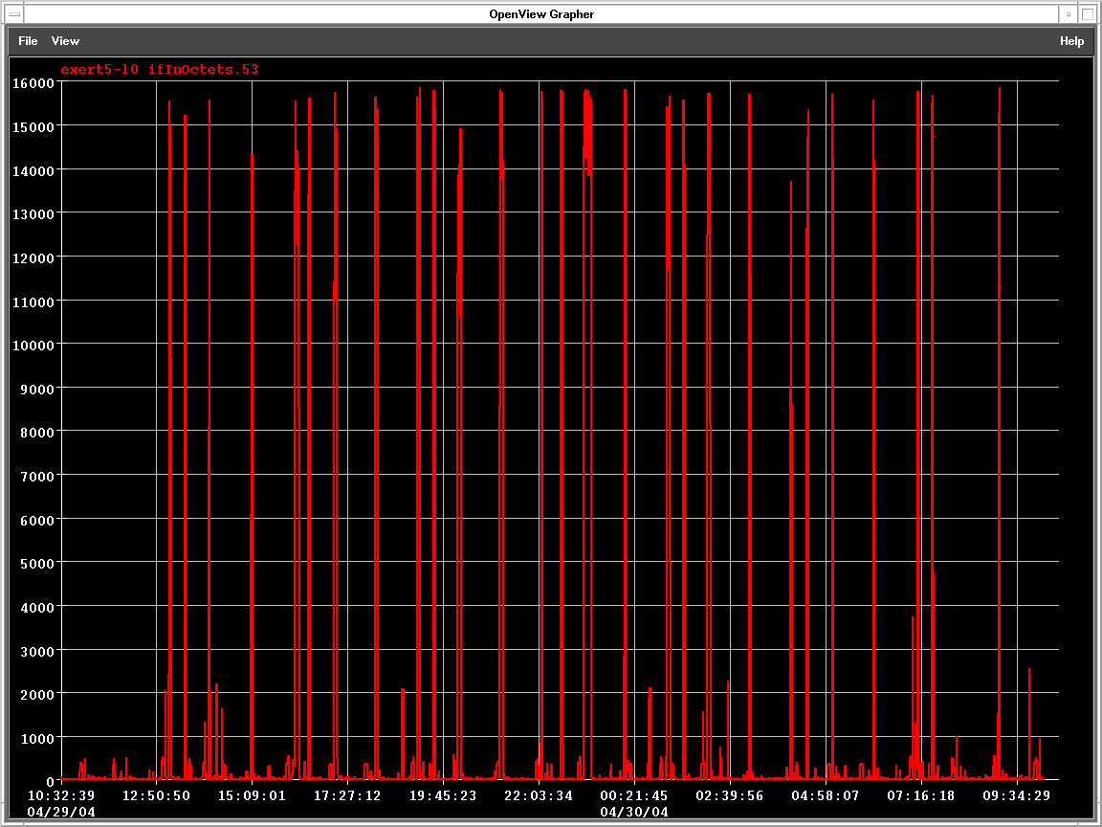
A5 ECMWF (Rx)

